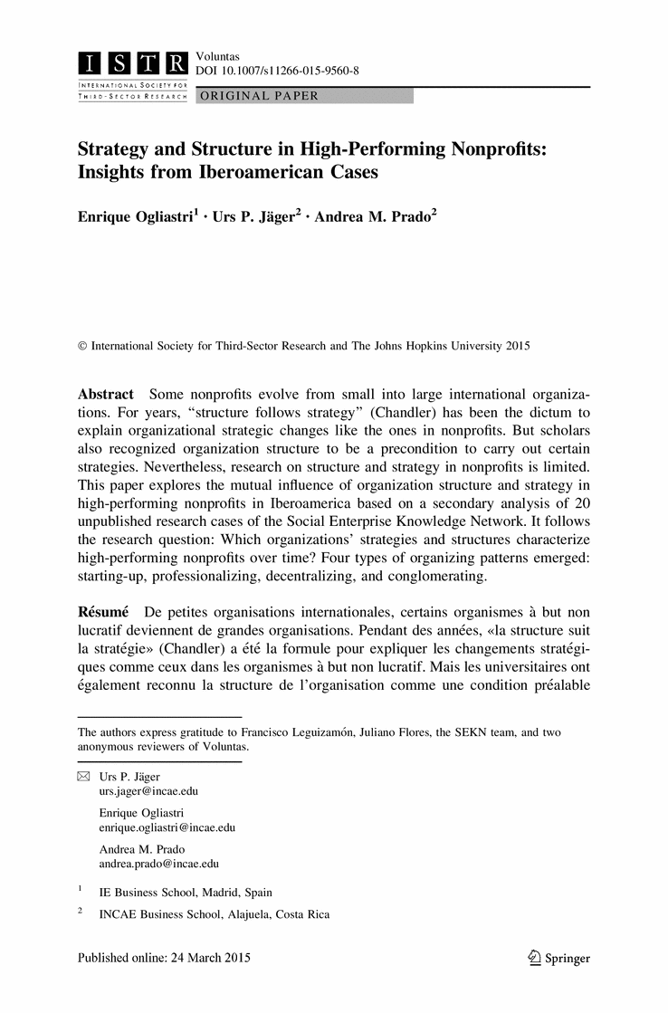
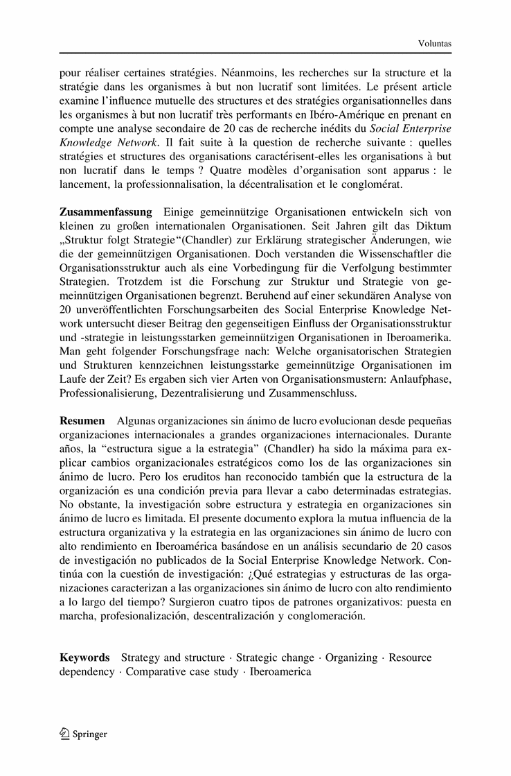

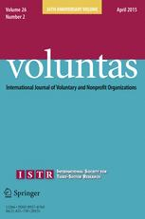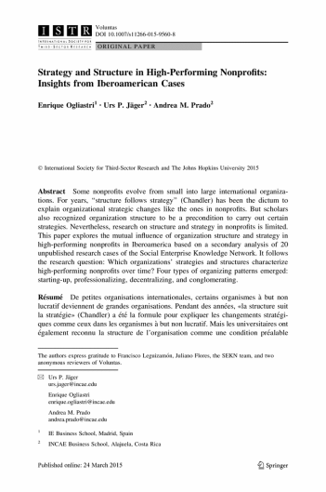Look
Inside

Article Metrics
Citations

Co-published with
- International Society for Third-Sector Research (ISTR)

Other actions
- Export citation
- Register for Journal Updates
- About This Journal
- Reprints and Permissions
- Add to Papers

Share
Share this content on Facebook Share this content on Twitter Share this content on LinkedIn


Supplementary Material (0)

References (50)
- Anheier, H (2005) Nonprofit organizations. Theory, management, policy. Routledge, London
- Austin, J (2006) Effective management of social entreprises. Lessons from Business and Civil Society Organizations in Iberoamerica. Harvard University Press, Cambridge, MA
- Austin, JE (2009) Aprovechar la convergencia. Academia Revista Latinoamericana de Administración 43: pp. 93-106
- Baker, D (2007) Strategic change management in public sector organizations. Chandos Publishing, Oxford
- Banaszak-Holl, J (1996) The impact of market and organizational characteristics on nursing care facility service innovation: A resource dependency perspective. Health Services Research 31: pp. 53-65
- Barney, J (2011) Twenty years of resource-based theory. Journal of Management 37: pp. 1299-1315
- Benbeniste, S (2004) Gob Menorca. Grupo Balera de ornitología y defensa de la naturaleza, Menorca: SEKN caso analítico. ESADE, Barcelona
- Berman, EM (1998) Productivity in public and nonprofit organizations. SAGE, Thousand Oaks
- Besel, K (2011) Nonprofit sustainability during times of uncertainty. Nonprofit Management and Leadership 22: pp. 53-65
- Chandler, A (1962) Strategy and structure: Chapters in the history of the American industrial enterprise. MIT Press, Cambridge, MA
- Chandler, A (1990) Scale and scope. Harvard University Press, Cambridge
- Channon, DF (1973) The strategy and structure of British enterprise. Graduate School of Busings Administration, Harvard University, Boston
- Courtney, R (2002) Strategic management for voluntary nonprofit organizations. Routledge, London
- Dyas, GP (1972) The strategy and structure of French industrial enterprise. Graduate School of Business Administration, Harvard University, Boston
- Etzioni, A (1964) Modern organizations. Prentice-Hall, Englewood Cliffs, NJ
- Evers, A Hybridisation in German public services—A contested field of innovation. In: Zimmer, A eds. (2012) Civil societies compared: Germany and The Netherlands. Baden-Baden, Nomos
- Flanagan, JC (1954) The critical incident technique. Psychological Bulletin 51: pp. 327-358
- Gonzáles, R (2004) Fe y Alegría: SEKN caso analítico. IESA, Caracas
- Graddy, EA, Morgan, DL (2006) Community foundations, organizational strategy, and public policy. Nonprofit and Voluntary Sector Quarterly 35: pp. 605-630
- Hammack, DC, Young, DW (1993) Nonprofit organizations in a market economy: Understanding new roles, issues, and trends: Understanding new roles, issues and trends. Jossey Bass, San Francisco
- Harris, M (2009) Strategic drift in international non-governmental development organizations-putting strategy in the background of organizational change. Public Administration 29: pp. 415-428
- Hoon, C (2013) Meta-synthesis of qualitative case studies: An approach of theory building. Organizational Research Methods 16: pp. 522-556
- Jackson, J, Morgan, C (1978) Organization theory: A macro perspective for management. McGraw Hill, New York
- Jäger, U, Beyes, T (2010) Strategizing in NPOs. A case study on the practice of organizational change between social mission and economic rationale. Voluntas 21: pp. 82-100
- James, E (2003) Commercialism and the mission of nonprofits. Society 40: pp. 29-35
- Kaplan, R, Norton, D (2006) Corporate strategy and structure: Historical perspective. Excerpted from a alignment: Using the balanced scorecard to create corporate synergies. Harvard Business School Publishing, Watertown
- Koljatic, M, Silva, M (2004) Asociación Chilena de Seguridad (ACHS): SEKN caso analítico. Pontificia Universidad Católica de Chile, Santiago de Chile
- Koljatic, M, Silva, M (2004) Corporación de Desarrollo Social del Sector Rural (Codesser): SEKN caso analítico. Pontificia Universidad Católica de Chile, Santiago de Chile
- Kreutzer, K, Jäger, U (2010) Volunteering versus managerialism: Conflict over organizational identity in voluntary associations. Nonprofit & Voluntary Sector Quarterly 40: pp. 634-661
- Letts, CW (1999) High performance nonprofit organizations. Managing upstream for greater impact. Wiley, New York
- Middleton-Stone, M, Crittenden, W (1993) A guide to journal articles on strategic management in nonprofit Organizations, 1977 to 1992. Nonprofit Management & Leadership 4: pp. 193-213
- Miller-Millesen, JL (2003) Understanding the behavior of nonprofit boards of directors: A theory-based approach. Nonprofit and Voluntary Sector Quarterly 32: pp. 521-547
- Moore, MH (2000) Managing for value: Organizational strategy in for-profit, nonprofit, and governmental organizations. Nonprofit and Voluntary Sector Quarterly 29: pp. 183-204
- Morrison, B, Salipante, P (2007) Governance for broadened accountability: Blending deliberate and emergent strategizing. Nonprofit and Voluntary Sector Quarterly 36: pp. 195-217
- Nicholls-Nixon, CL (2011) Latin America Management Research: Review, synthesis, and extension. Journal of Management 37: pp. 1178-1227
- Nohria, N. (1995). Note on organizational structure. Technical Note. Boston: Harvard Business School.
- Odom, RY, Boxx, WR (1988) Environment, planning processes, and organizational performance of churches. Strategic Management Journal 9: pp. 197-205
- Ogliastri, E., & Leguizamón F. (2004). (Eds.) Alianzas cívicas. Casos latinoamericanos sobre la colaboración entre empresas y organizaciones de la sociedad civil. Academia Revista Latinoamericana de Administración, vol. 31 (Bogotá: CLADEA, 2003, p. 152).
- Pavan, RJ (1972) The strategy and structure of Italian enterprise. Graduate School of Business Administration, Harvard University, Boston
- Pettigrew, A (1990) Longitudinal field research on change: Theory and practice. Organization Science 1: pp. 267-292
- Roitter, M (2004) La Fundación Pro Vivienda Social: SEKN caso analítico. Universidad de San Andrés, Buenos Aires
- Rothschild, J, Milofsky, C (2006) The centrality of values, passions, and ethics in nonprofit sector. Nonprofit Management & Leadership 17: pp. 137-143
- Salipante, PF, Golden-Biddle, K (1995) Managing traditionality and strategic change in nonprofit organizations. Nonprofit Management & Leadership 6: pp. 3-20
- Sanabria, R (2004) La Asociación Probienestar de la Familia Colombiana, Profamilia: SEKN caso analítico. Universidad de los Andes, Bogotá
- Saz, Á, Vernis, A (2004) Intermón Oxfam: SEKN caso analítico. ESADE, Barcelona
- Thanheiser, HT (1972) Strategy and structure of German industrial enterprise. Graduate School of Business Administration, Harvard University, Boston
- Trujillo, D, Gómez, M (2004) Mejores prácticas en emprendimiento social. COLSUBSIDIO: Emprendimientos sociales desarrollados por una empresa privada sin ánimo de lucro: SEKN caso analítico. Universidad de los Andes, Bogotá
- Valeau, P. J. (2014). Stages and pathways of development of nonprofit organizations: An integrative model. Voluntas (Published online).
- Weber, M (1978) Economy and Society. University of California Press, Berkeley, Los Angeles
- Young, DR (2002) The influence of business on nonprofit organizations and the complexity of nonprofit accountability: Looking inside as well as outside. The American Review of Public Administration 32: pp. 3-19

About this Article
Title
Strategy and Structure in High-Performing Nonprofits: Insights from Iberoamerican Cases
Journal
VOLUNTAS: International Journal of Voluntary and Nonprofit Organizations
DOI
10.1007/s11266-015-9560-8
Print ISSN
0957-8765
Online ISSN
1573-7888
Publisher
Springer US
Additional Links
- Register for Journal Updates
- Editorial Board
- About This Journal
- Manuscript Submission
Topics
- Social Sciences, general
- Political Science, general
- Social Policy
Keywords
- Strategy and structure
- Strategic change
- Organizing
- Resource dependency
- Comparative case study
- Iberoamerica
Industry Sectors
- Finance, Business & Banking
Authors
- Enrique Ogliastri ⁽¹⁾
- Urs P. Jäger ⁽²⁾
- Andrea M. Prado ⁽²⁾
Author Affiliations
- 1. INCAE (Costa Rica) & IE Business School, Madrid, Spain
- 2. INCAE Business School, Alajuela, Costa Rica

Continue reading...
To view the rest of this content please follow the download PDF link above.

摘要
某些非营利组织由小变大,成为大型国际机构。数年以来,“结构跟随战略”(钱德勒)已成为解释类似非营利组织的战略变化的格言。但也有学者认为组织结构是执行特定战略的先决条件。虽然如此,非营利组织结构和战略研究受到限制。通过分析20个未公布的社会企业知识网络研究案例,本文探索了伊比利亚美洲高绩效非营利组织的组织结构和战略之间的相互影响。随后的问题是:高绩效非营利组织采用何种战略和结构?现有四种组织类型,即创业型,专业型,分散型和联合型。

要約
非営利団体には、小規模な国際組織から大規模なものに発展するものがある。「戦略に続く構造」(チャンドラー)における非営利団体のように、長年にわたって戦略的な変更が説明されているものがある。しかし、学者は特定の戦略を遂行する前提条件である組織構造を認識している。それにもかかわらず、非営利団体の構造と研究戦略は制約されている。本論文では、組織構造の相互の影響と社会的企業の知識ネットワークにおける未発表研究20事例の二次分析に基づいて、イベロアメリカにおける実現可能な非営利団体の戦略を調査する。本研究の疑問点は、どの組織の戦略と組織構造が、時間をかけて実現可能な非営利団体を特徴付けるかである。4種類の型としては、開始、専門職化、分散、複合化があげられる。

ملخص
بعض المنظمات الغير ربحية تتطور من منظمات صغيرة إلى منظمات دولية كبيرة. لسنوات، “هيكل يتبع إستراتيجية” (Chandler) كان القول المأثور لشرح التغييرات الإستراتيجية مثل تلك الموجودة في المنظمات الغير ربحية. لكن العلماء أيضا˝ تعترف بالهيكل التنظيمي ليكون شرط مسبق لتنفيذ إستراتيجيات معينة. مع ذلك، البحث عن الهيكل والإستراتيجية في المنظمات الغير ربحية محدود. يحلل هذا المقال التأثير المتبادل للهيكل التنظيمي والإستراتيجية في إرتفاع أداء المنظمات الغير ربحية في البلدان الأيبيرية الأمريكية إستنادا˝ إلى التحليل الثانوي من 20 حالة بحوث غير منشورة من شبكة معرفة المؤسسة الإجتماعية. تتابع سؤال البحث: ما هي إستراتيجيات المنظمات والهياكل التي تميز المنظمات الغير ربحية عالية الأداء مع مرور الوقت؟ أربعة أنواع من أنماط تنظيم ظهرت: الإعداد ، المهني، اللامركزي، وعدد من البنود التي يتم تجميعها معا˝.
The authors express gratitude to Francisco Leguizamón, Juliano Flores, the SEKN team, and two anonymous reviewers of Voluntas.
Page %P
Close

